Year 3 Newsletter Term 2, 2025
Dates to Remember  Shrine Excursion Wednesday 23rd April  ANZAC Day (Public Holiday) Friday 25th April  School Photos Tuesday 6th May  Mothers Day Stall Thursday 8th May  Grade 3/4 Fundraiser Wednesday 4th June  King's Birthday (Public Holiday) Monday 9th June  Melbourne Museum Excursion Wednesday 11th June  Pupil Free Day Monday 23rd June  Yarra River Cruise Excursion Wednesday 25th June  Grade 3 - 5 Concert Wednesday 2nd July  Last Day of Term 2 Friday 4th July  First day of Term 3 Monday 21st July  Welcome back students, parents and guardians! It is great to see the children well rested and ready to learn! We have got a jam packed term with school photos, excursions, incursions, and to finish it off... a fabulous concert!  The teachers in the Year 3 Department are:  - Mr Thomas Gath (Room 7)  - Miss Kimberly Tran (Room 8)  OTHER PARENT INFORMATION  - We encourage students to arrive on time before the 9am bell to maximise their learning opportunities.  - Homework is given out on Mondays and is to be handed in by Friday.  - Students are to read their take home books each day for 20 minutes. They are to record their reading in their diaries. The reading diaries are checked once a week by the classroom teacher.    HOMEWORK  Homework will be handed out every Monday starting in week 2. This will consist of revision of concepts learnt in class.  Make sure homework is handed in every Friday for the classroom teacher to check.  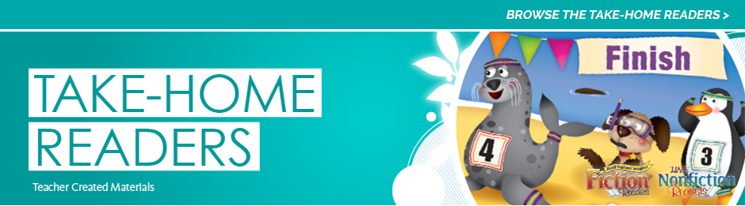  TAKE HOME READING  Year 3 students will be asked to read at least 20 minutes a day at home to a family member if possible. The students are asked to read 5 times a week and record their daily reading in their reading diaries. Please sign your child’s take home diary each day they have read and record date, title and a comment if you like.  Make sure their take home diary is placed back into their reading satchels for the teacher to check every Friday. | Curriculum Overview  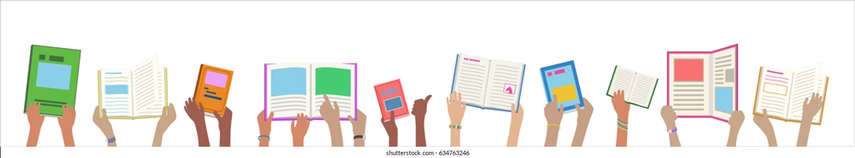  READING  This term in Reading, students are working on questioning in order to better understand what they read. Students are also working on asking clarifying questions about parts of texts or unknown words. Students will learn about features of fiction and non-fiction texts.  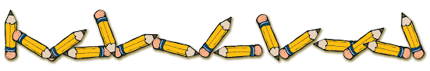  WRITING  This Term in Writing the Grade 3 students will be applying their writing skills to use elements such as transition words, conjunctions, adverbs and challenging vocabulary. Students will write an information report and letters, along with creating a travel brochure.  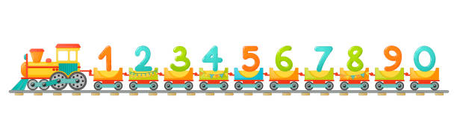MATHEMATICS  In Maths this term, students will be learning about measurement in terms of length and mass. They will also be introduced to location and transformation. The Grade 3 students will continue to recall multiplication facts and use their knowledge to help with their division facts. The students will continue to collect data and interpret various graphs.    HUMANITIES  In Humanities this term, the grade 3 students will improve their questioning, research, and mapping skills as they learn more about Australia and our island neighbours. They will investigate climate zones, food chains, biomes, and different rock formations. Students will consider the symbols, values, and identities of different island nations. This unit culminates in the collaborative planning, modelling, and mapping of a new island.

